Volcano Princess does have clearly defined levels; each month is like a small chapter to explore. So I would like to analyze the fighting zone, which is the forest that has some monsters in it.
First, you have to choose which sections of the forest you want to go to. It separates the harder sections(shown in Figure 1). In those sections, you can choose one of those two paths(shown in Figure 2). There will be several times when you can choose where to go. All the paths look the same based on the art or lighting; it's dark around those paths. What makes those paths different is the different event that is shown on the paths. It has only one playstyle, which is a turn-based game. The character and their teammate use action points to use skills to fight.

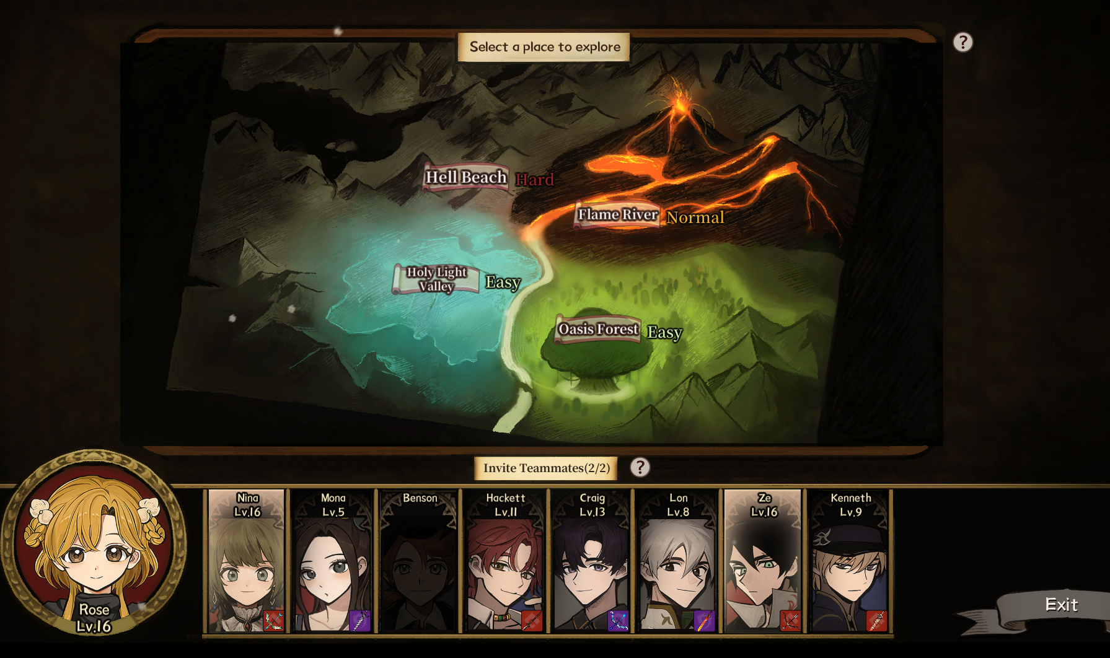
(Figure 1: forest’s map)

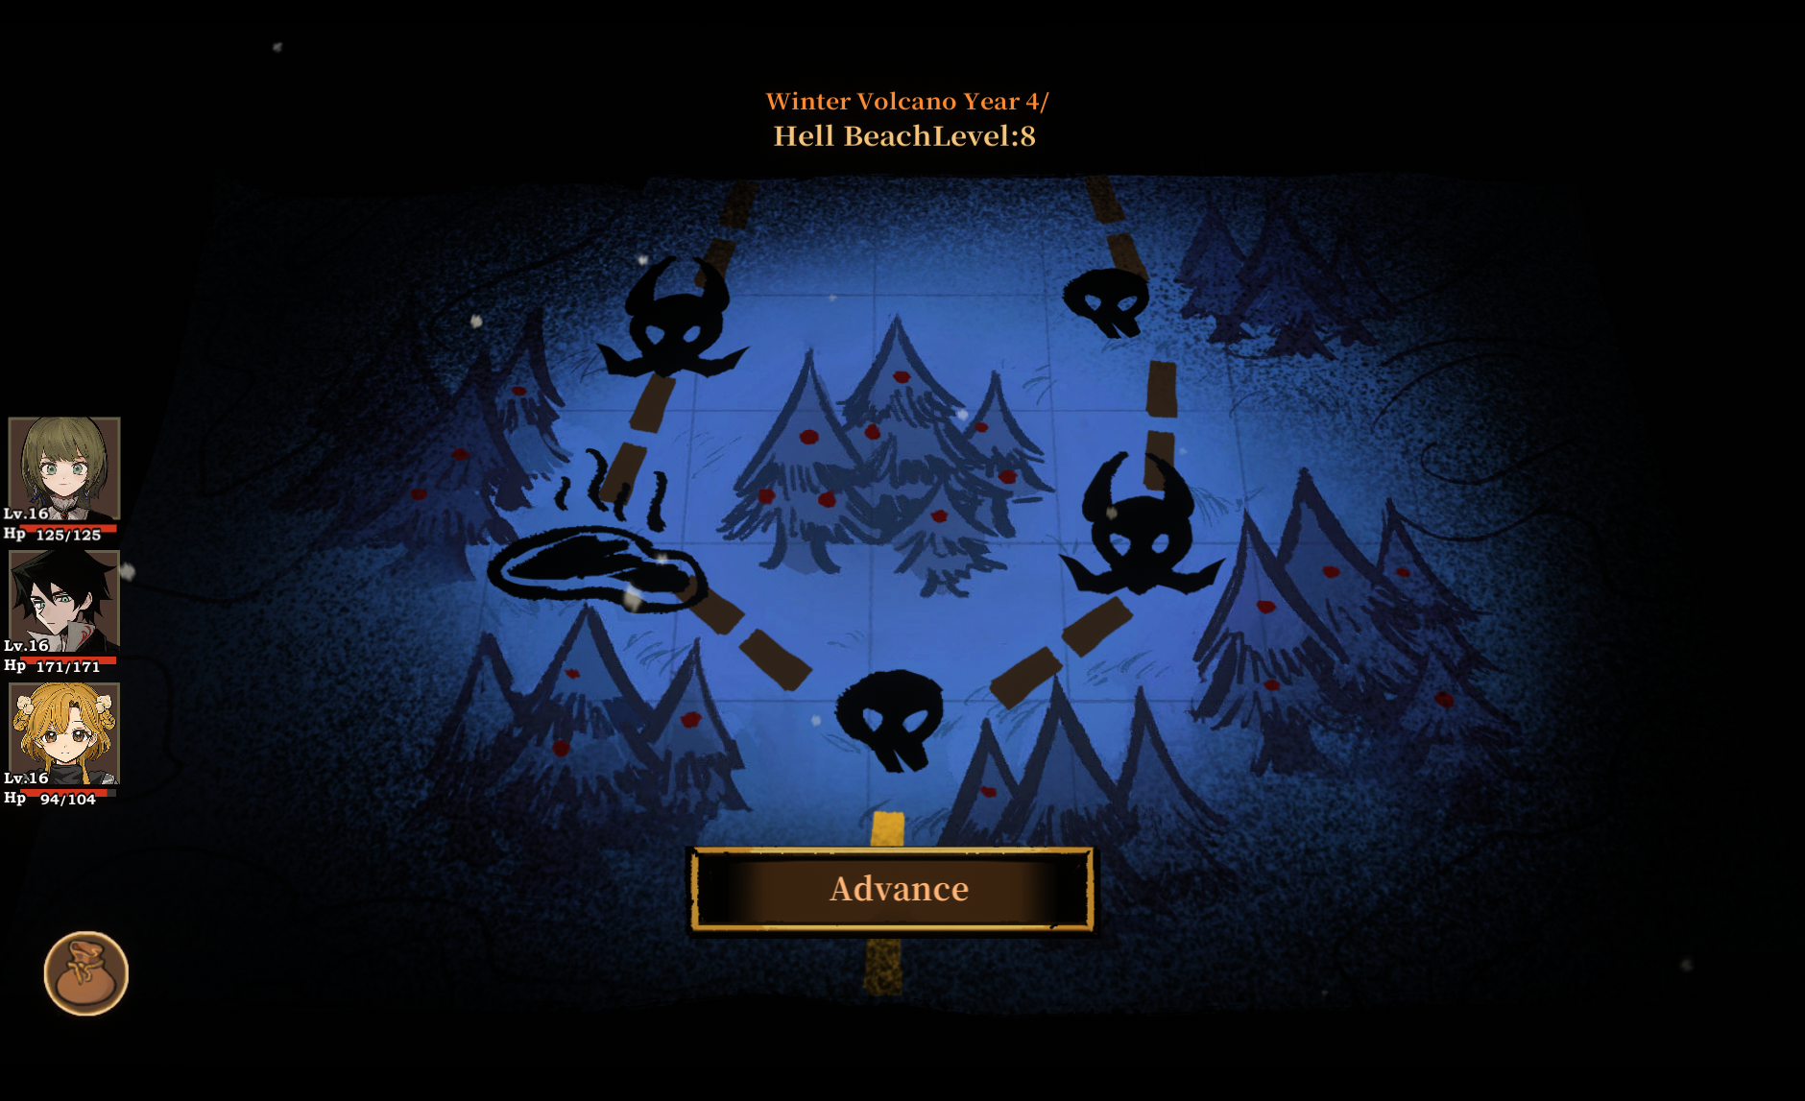
(Figure 2: paths)
There are several static events, such as how both characters and monsters attack(shown in Figure 3). Characters can use skills to attack, gain shields, and heal. Monsters can attack, enhance, and curse. The team also chooses paths each time.
The one-time events in this zone are the events that you meet on the path that you choose, such as random events, opening chests, meeting monsters, and healing pools. They can be missed based on what paths you choose. Those events can give rewards or bad effects to the character/team, which makes the path decision more important.

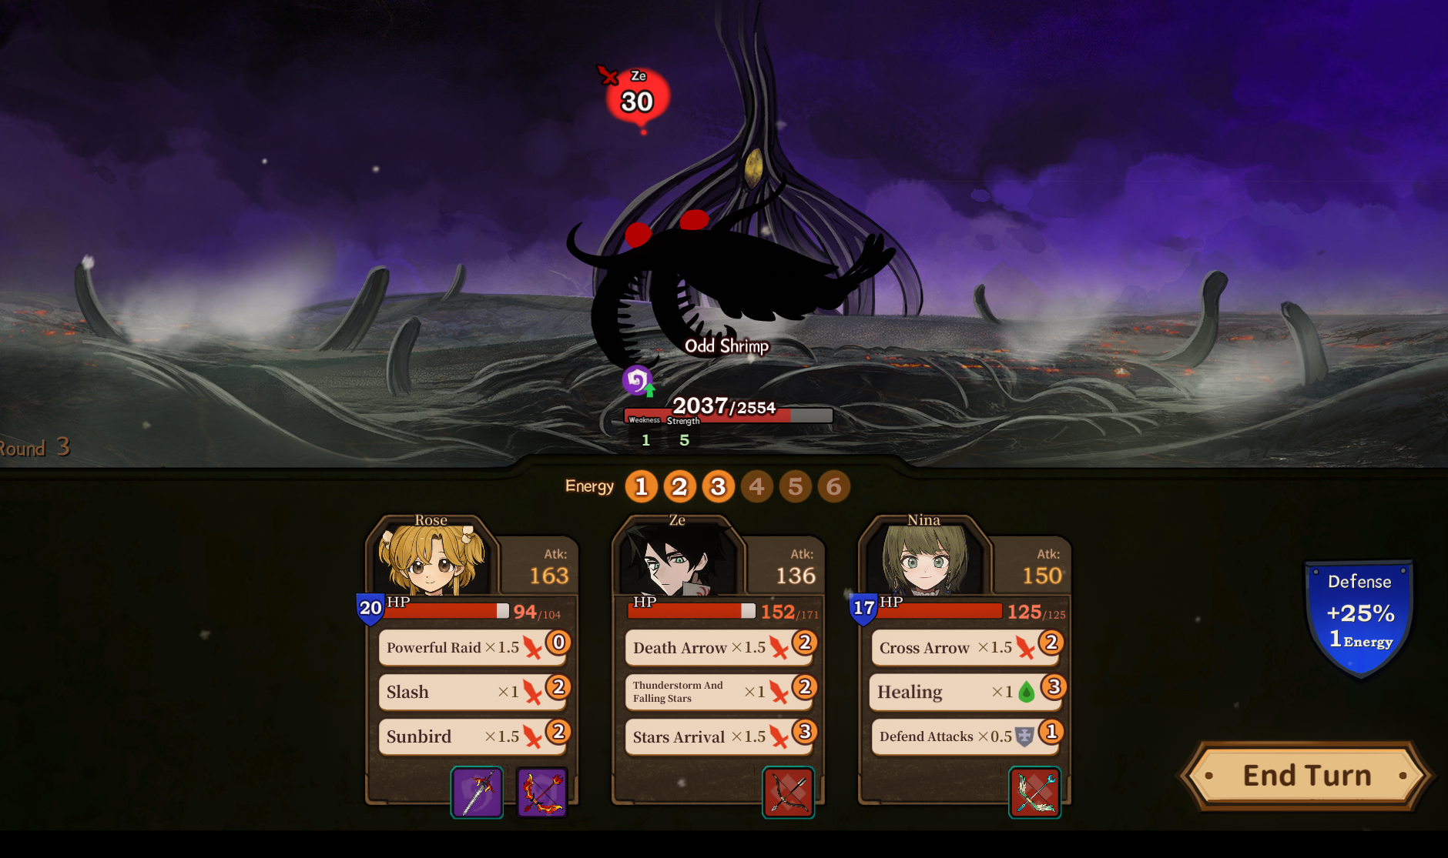
(Figure 3: fighting scene)

The basic blockout shapes are shown in Figure 4. The central spaces are the “Choose Path” area and the event areas that follow it. The Choose Path area acts as the main hub because the player repeatedly returns to this decision point and selects between healing pools, random events, chests, and monster encounters.
I would change the skills in the mechanism; I want to have more skills, because right now the skills are too basic. I would like to add skills in the mechanism part, like gaining more action points next turn because it only gains a certain amount of energy points each turn, or buffing a teammate. This allows teams to collaborate more effectively, rather than each working in isolation.
Right now the fighting design is way too simple; the battles are mostly text-based, showing only character portraits and skills; only monsters have illustrations. Adding artistic elements, such as character illustrations or 2D attack animations, would significantly alter the style of the combat. For instance, the changes I mentioned could completely transform the combat style into a 2D fighting game format.
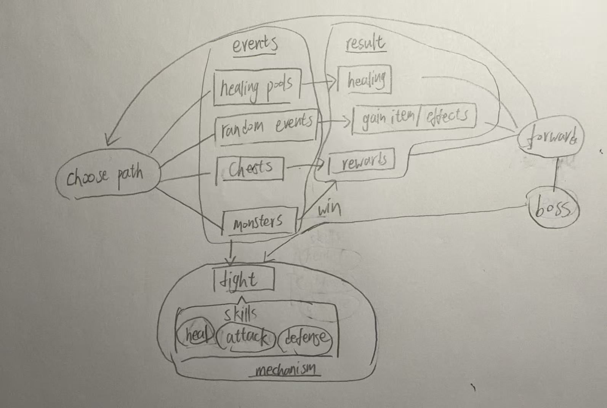
(Figure 4: hand-drawing basic blockout shapes)

